K. SANJANA
2505A41L63
Q1. Reverse Linked List
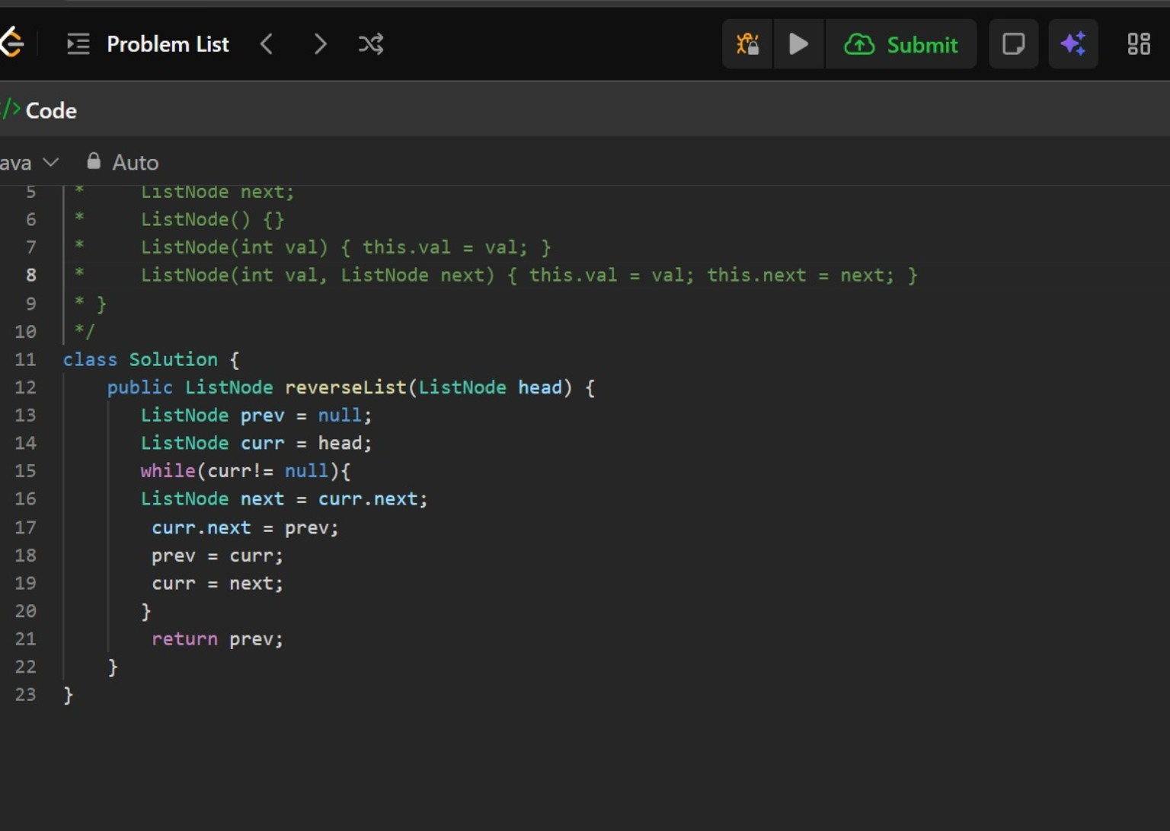
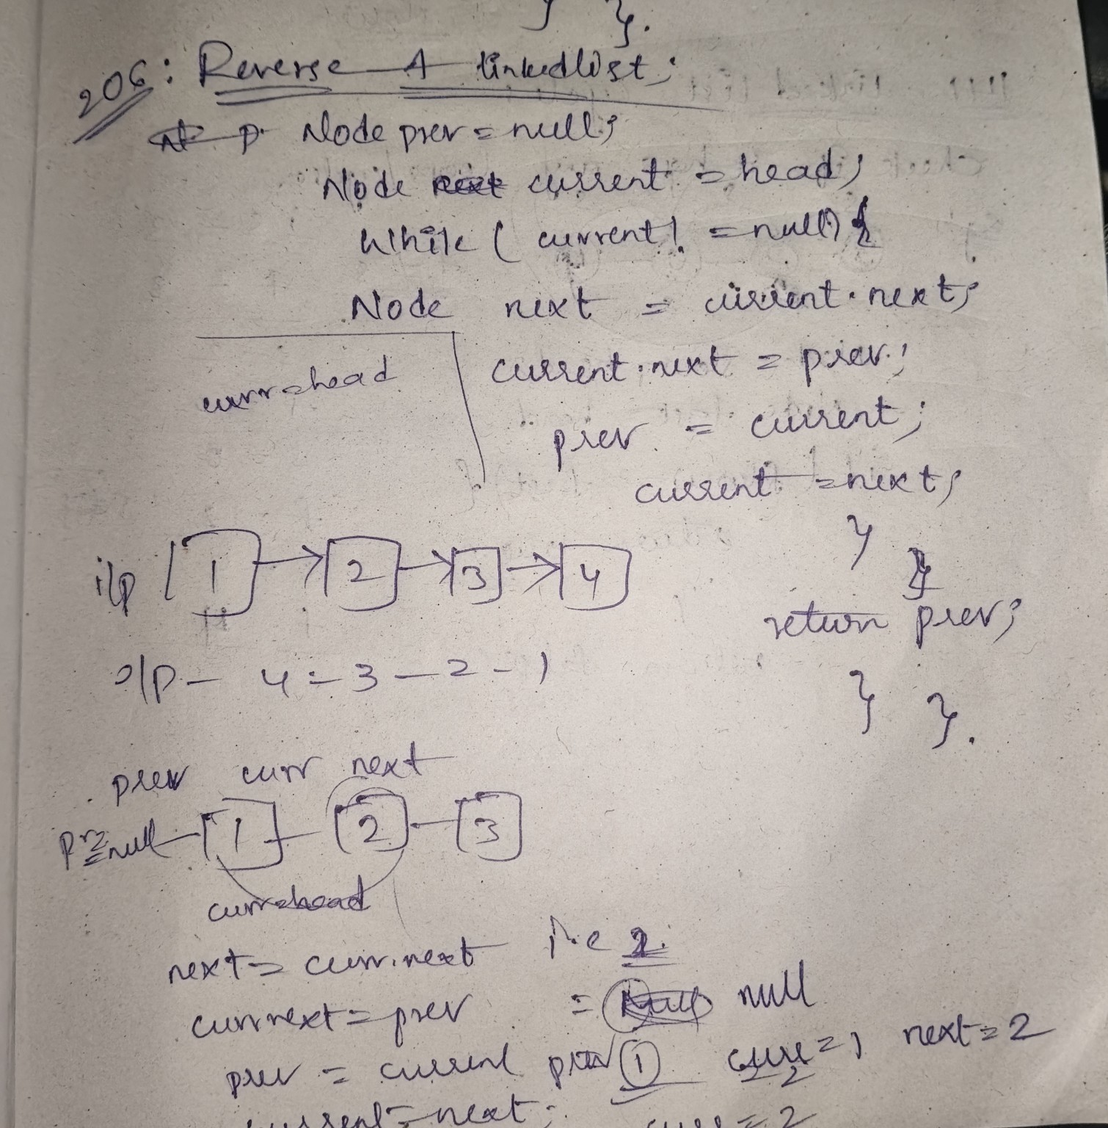
LeetCode link: https://leetcode.com/problems/reverse-linked-list/

Q2. Middle of the Linked List
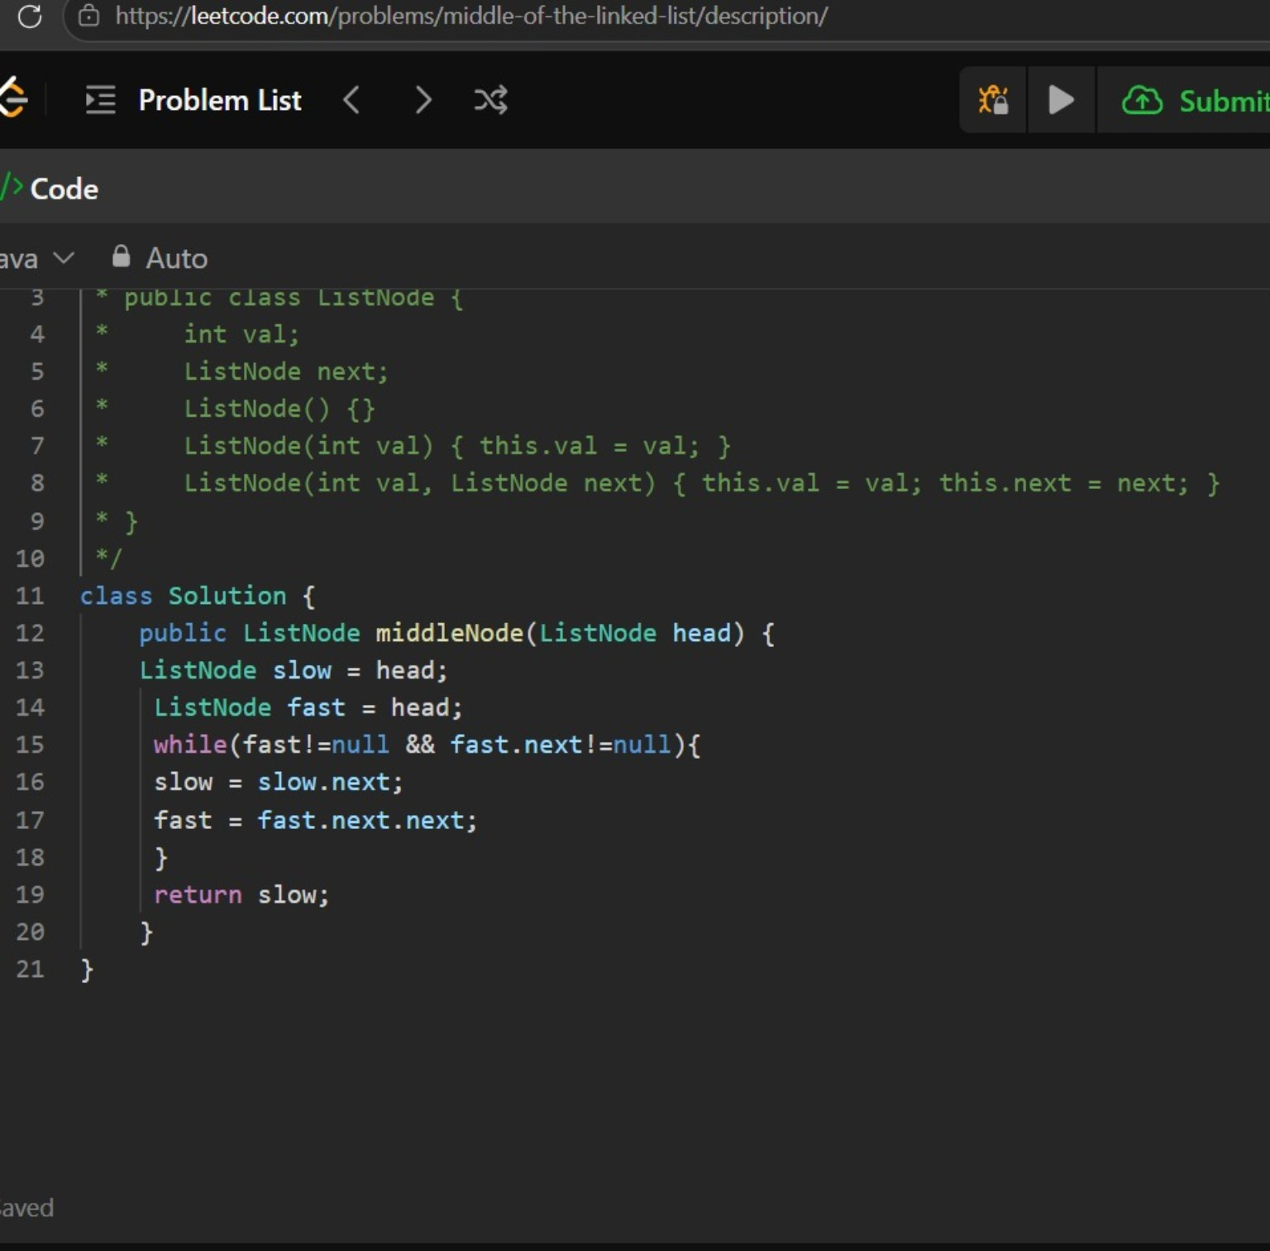
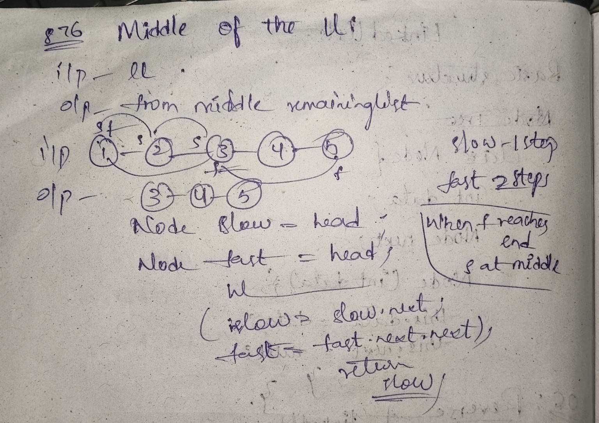
LeetCode link: https://leetcode.com/problems/middle-of-the-linked-list/

Q3. Linked List Cycle
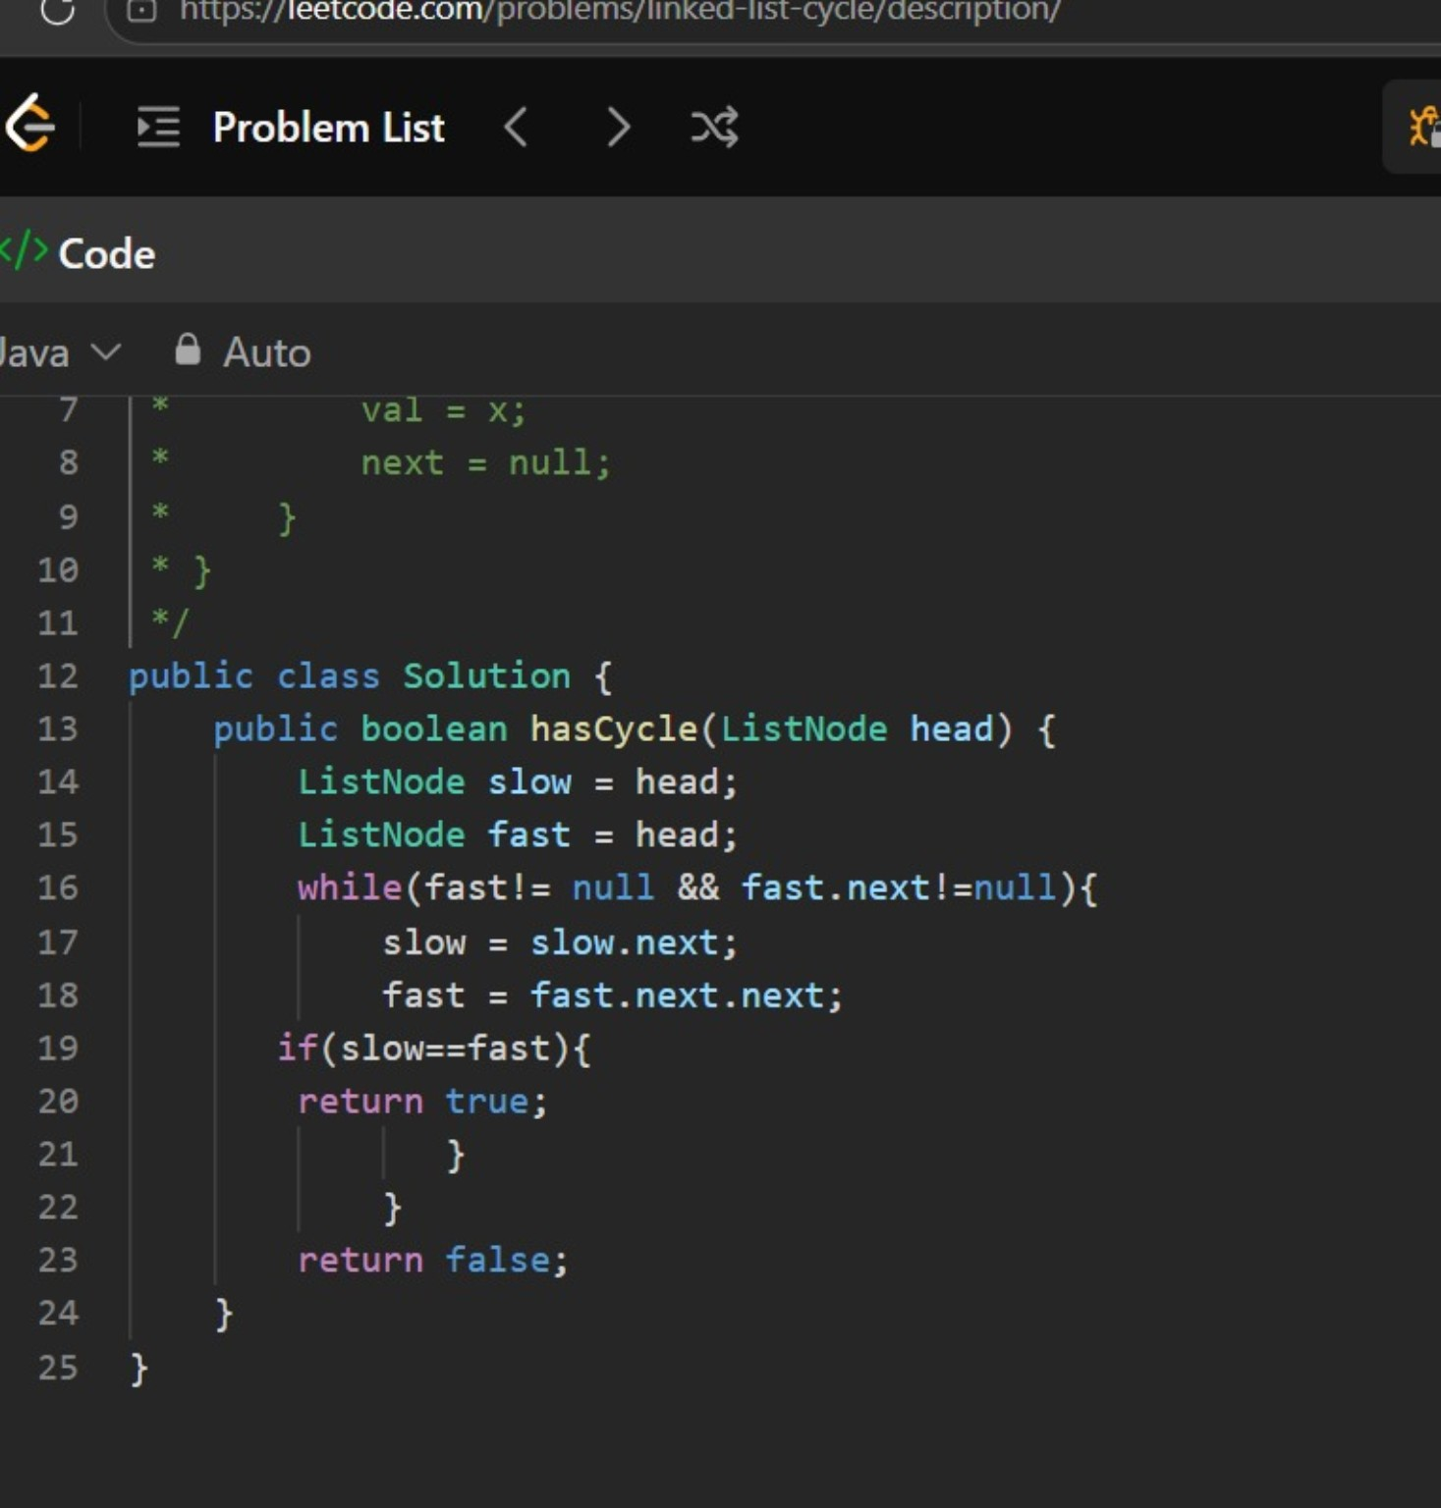
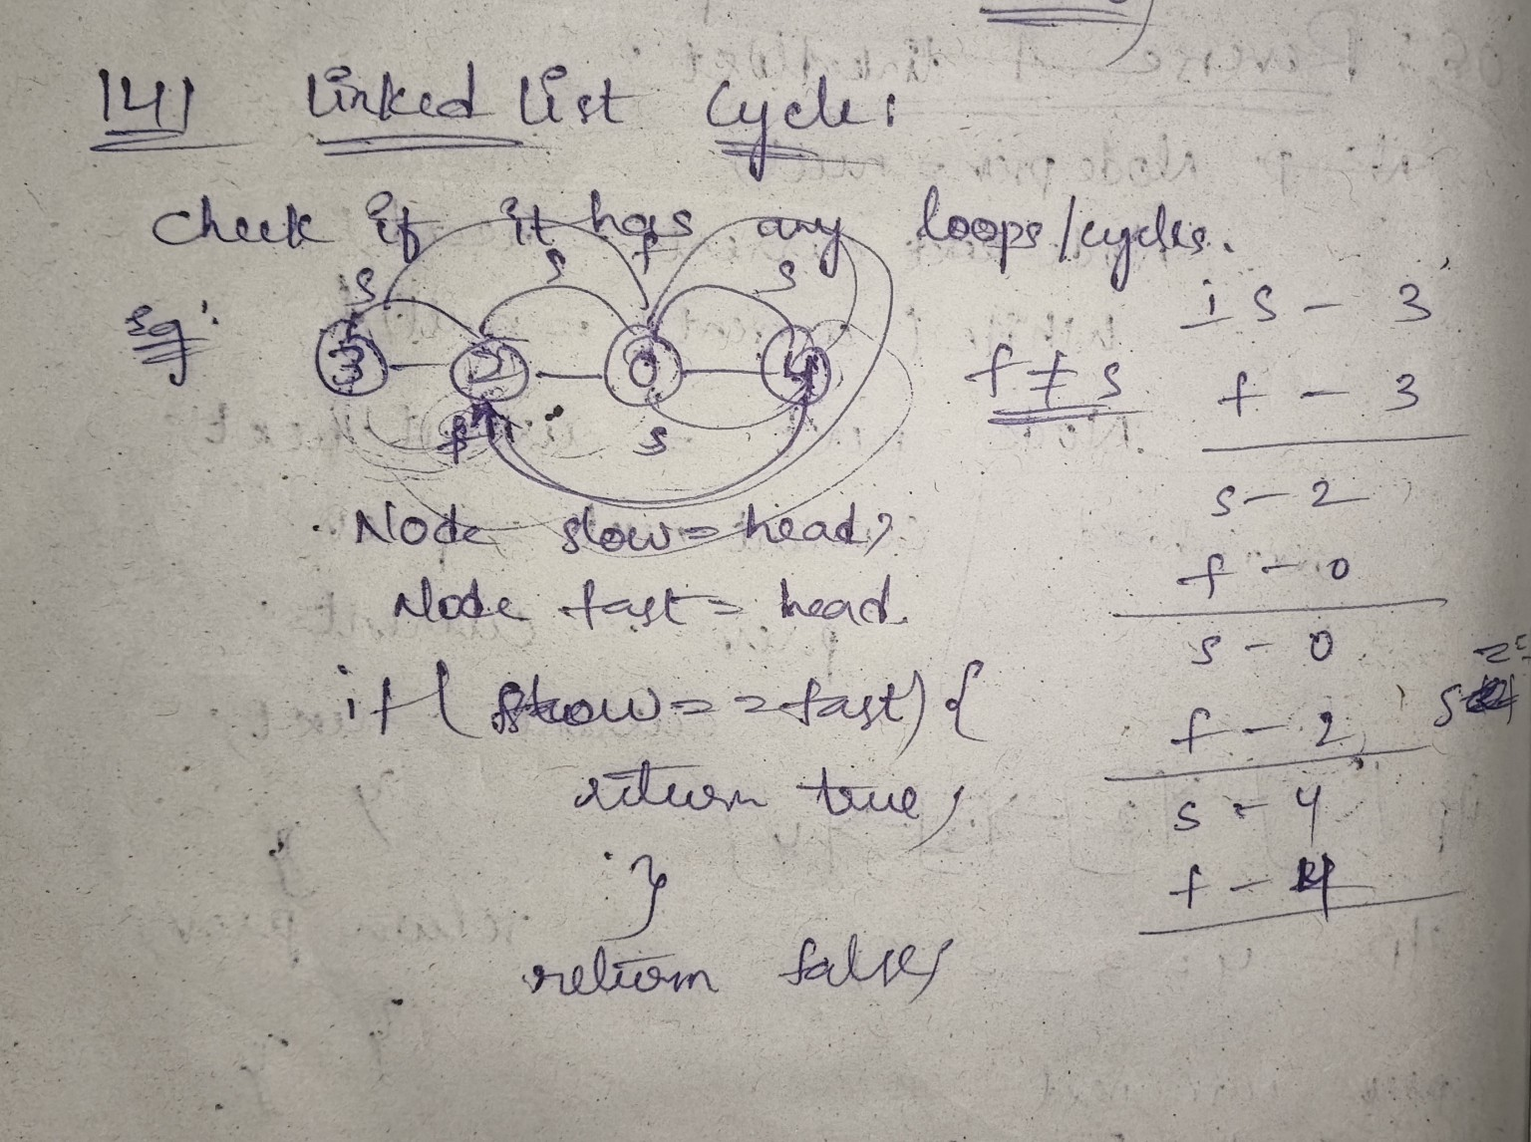
LeetCode link: https://leetcode.com/problems/linked-list-cycle/

Q4. Merge Two Sorted Lists
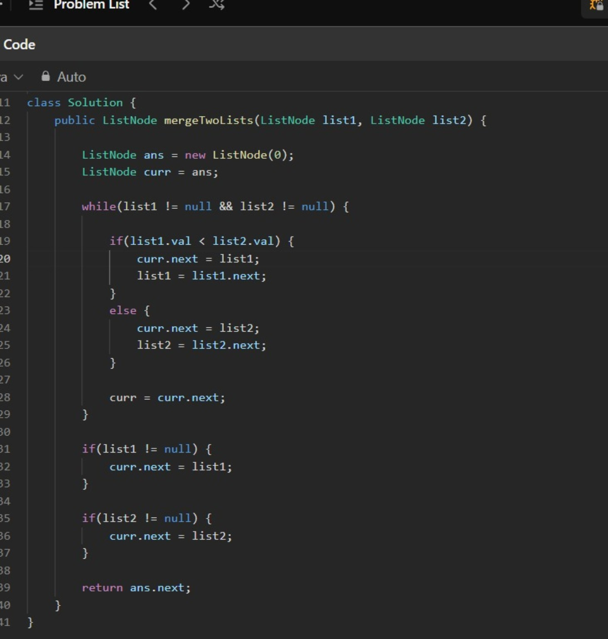
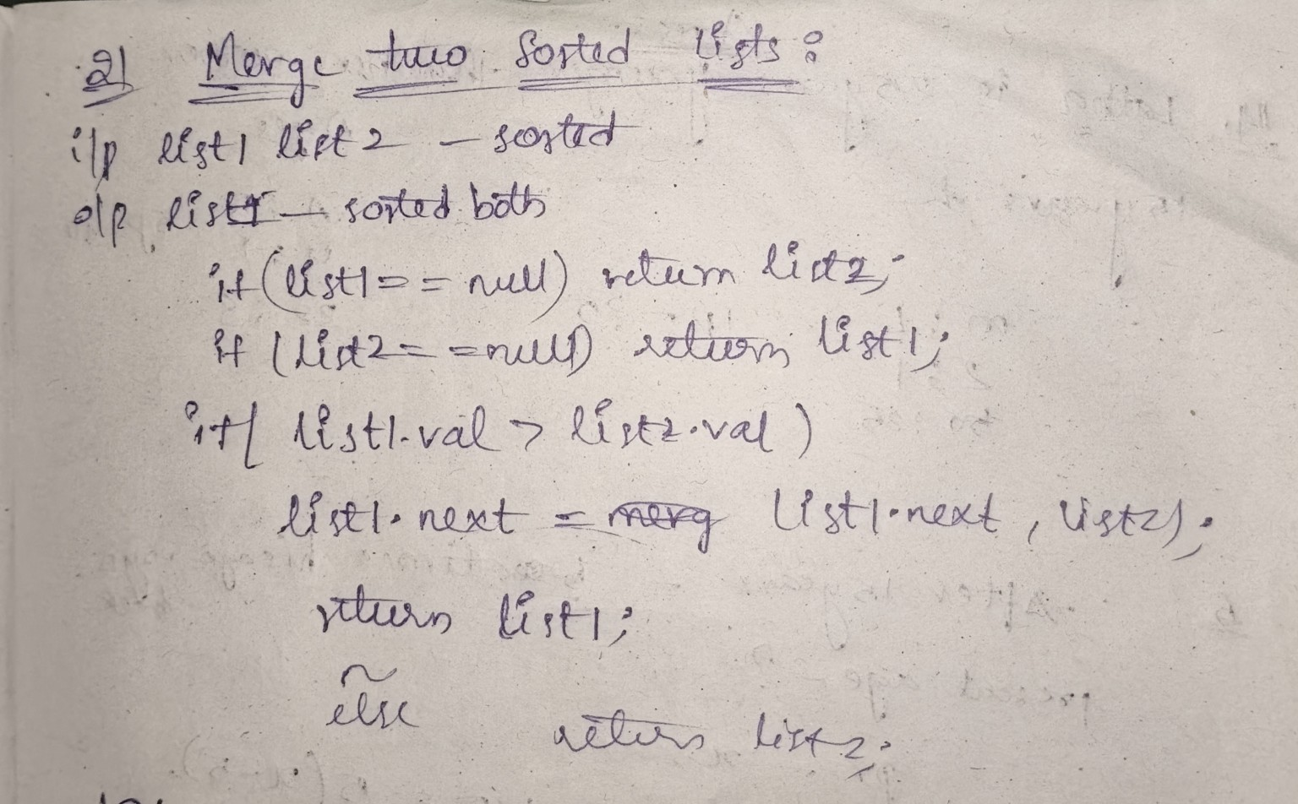
LeetCode link: https://leetcode.com/problems/merge-two-sorted-lists/

Q5. Remove Nth Node From End of List
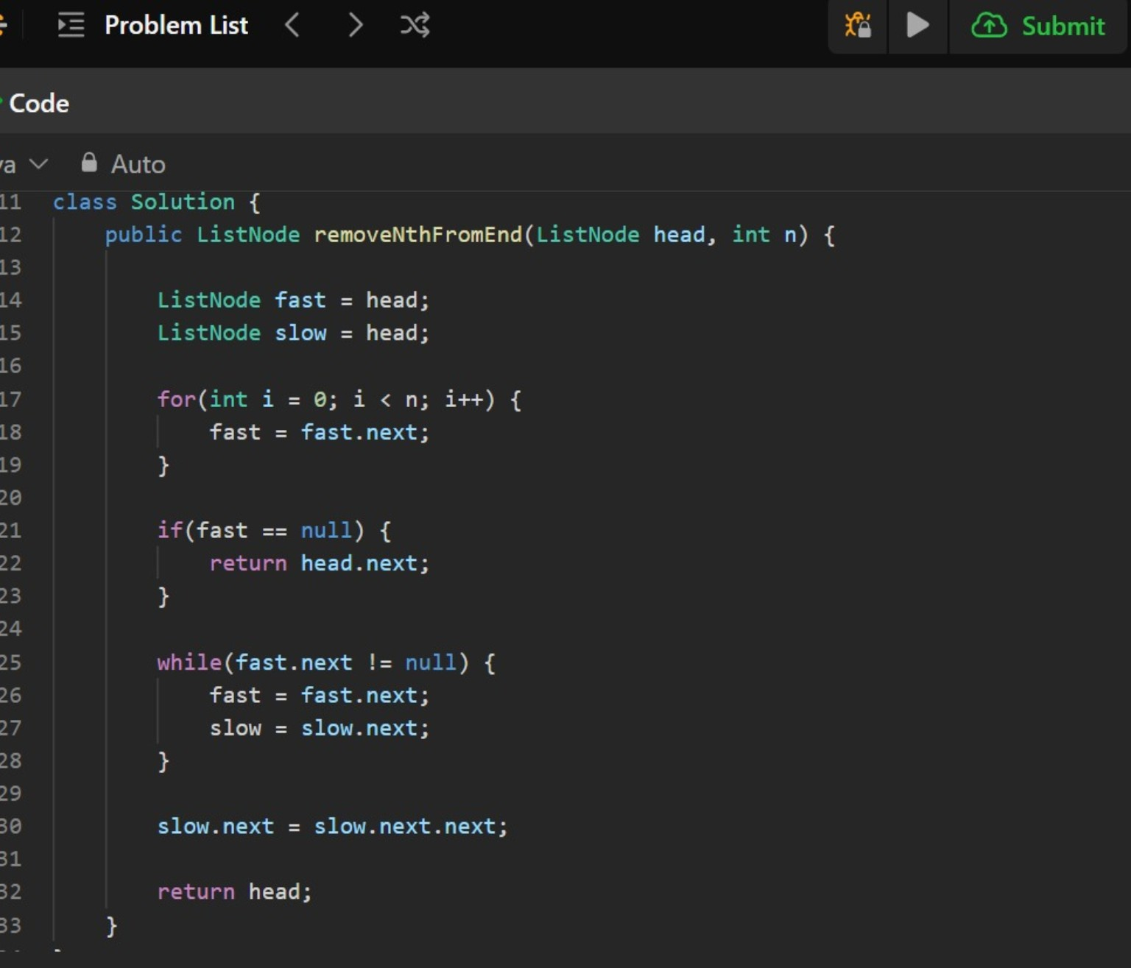
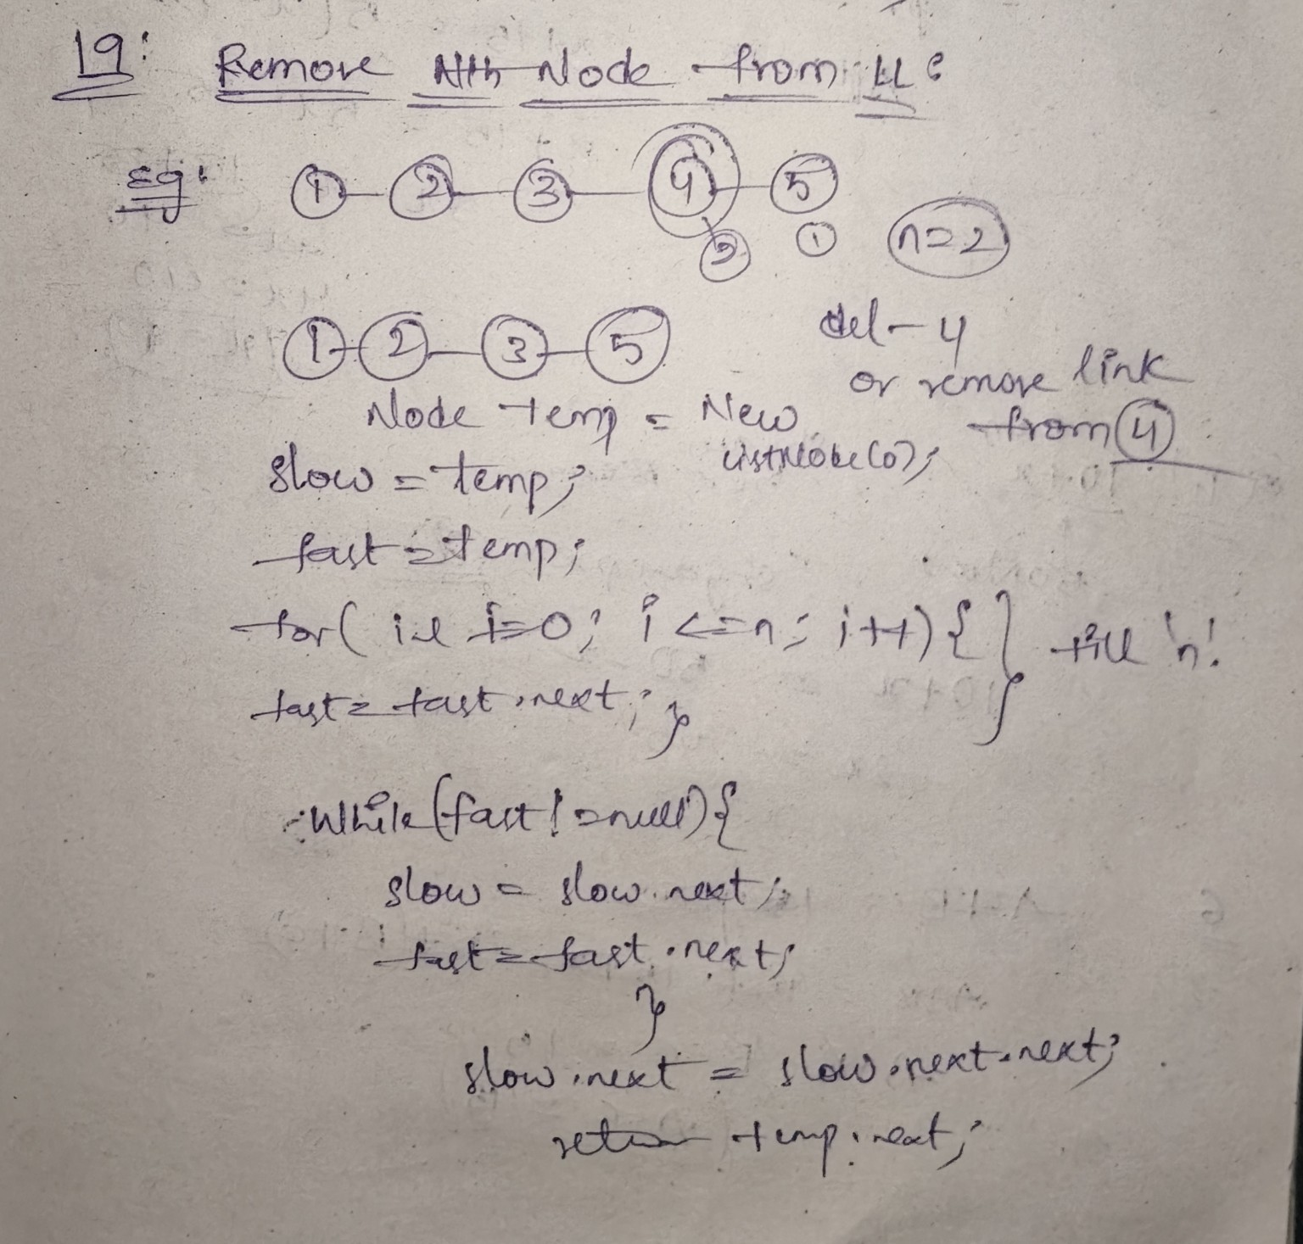
LeetCode link: https://leetcode.com/problems/remove-nth-node-from-end-of-list/

